Report By | Company: |  | Ph:
 | ATTN: |  | Email:

Report For | Company: | @@JobCompName | Ph:
 | ATTN: | @@JobCustName | Email:

Site Address | 49 Escarpment  Cabarlah QLD 4352, Australia | Job Number
 | 49 Escarpment  Cabarlah QLD 4352, Australia | @@JobNumber

Summary of Lengths, Areas and Pitches
Total Area | 587.18 m² | Pitch(es) | 25
Corrugated | 587.18 m² | Eave | 95.93 m
Gable | 25.88 m | Hip | 81.0 m
Ridge | 46.16 m | Roof Batten 40MM | 1036.03 m
Valley | 75.51 m
Plan Image
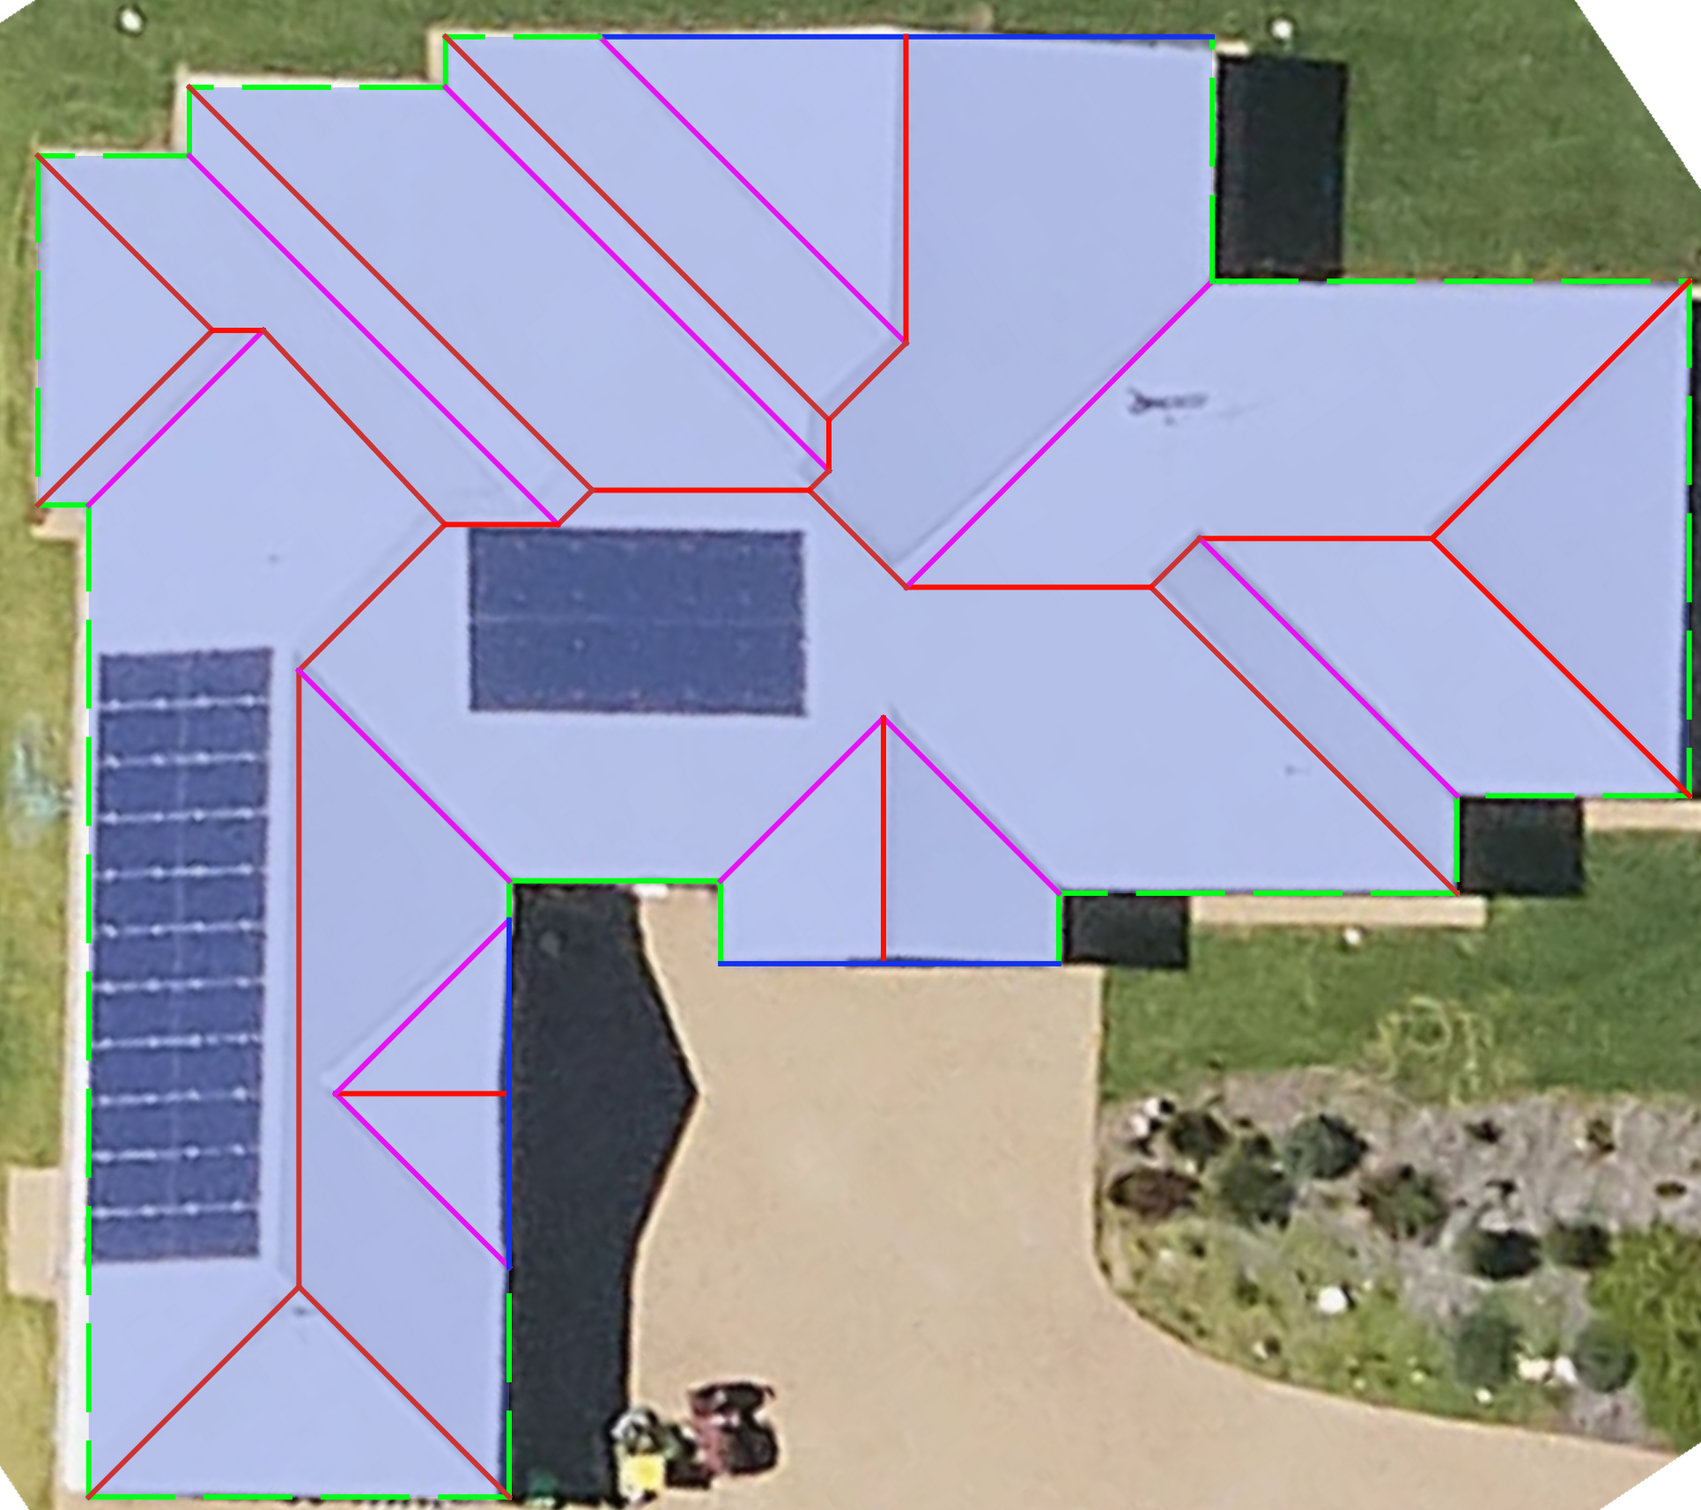

Point Items, Dimensions and Line Types
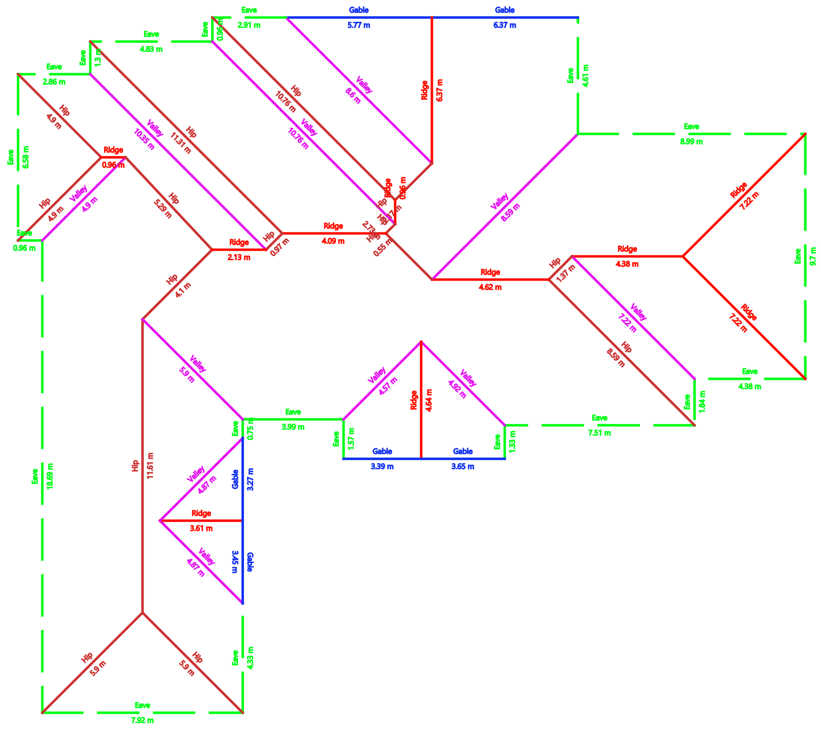

Total Line Lengths
Eave | 95.93 m | Gable | 25.88 m
Hip | 81.0 m | Ridge | 46.16 m
Valley | 75.51 m

Plane Pitches/Slopes and Areas
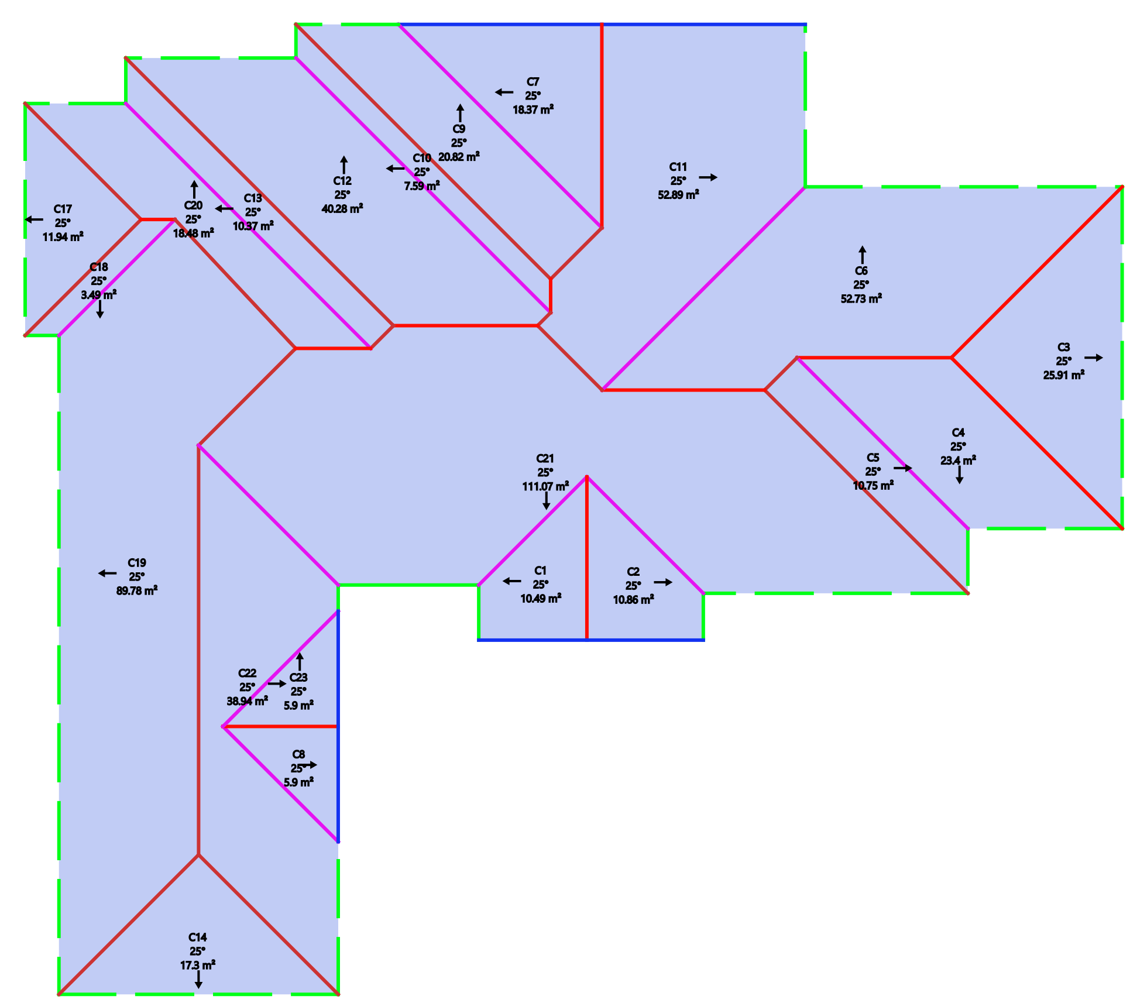

Pitch | Area
25 | 587.18 m²
Total | 587.18 m²

Flashings
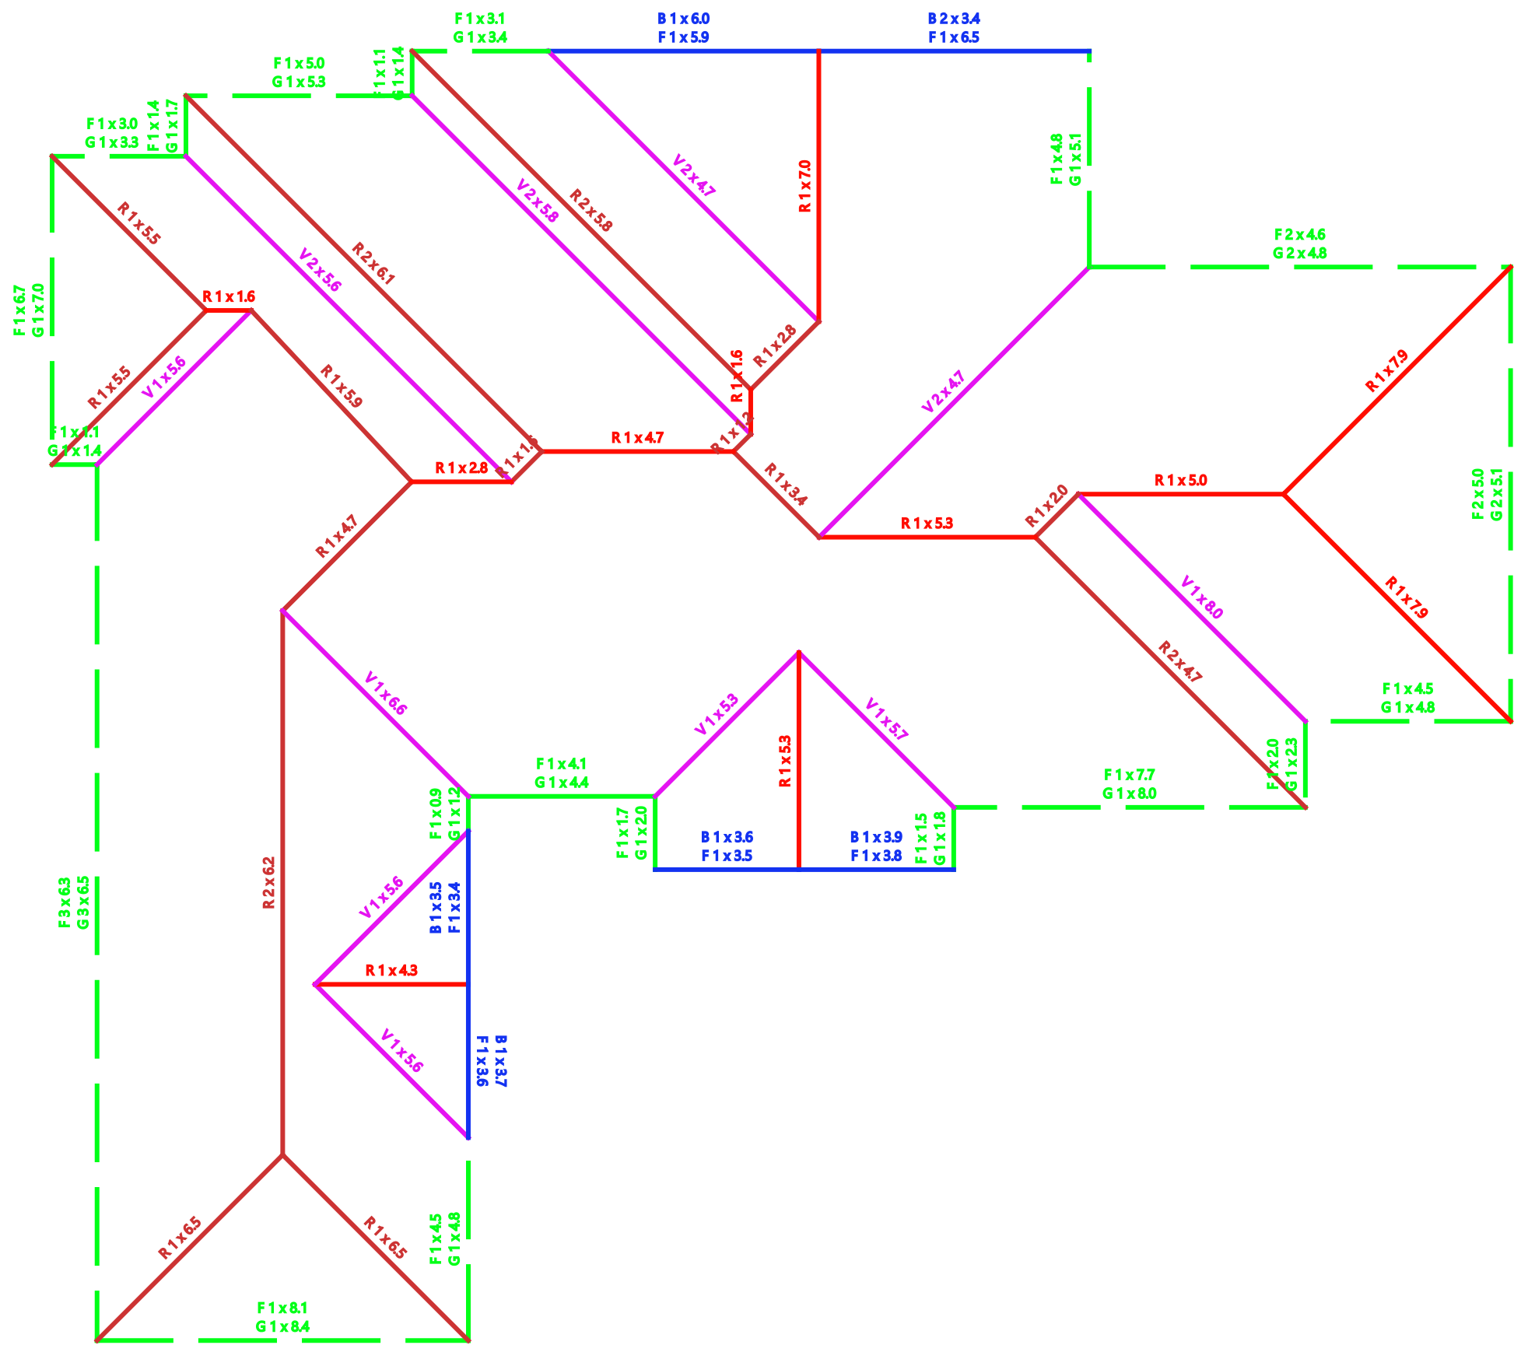

Panels
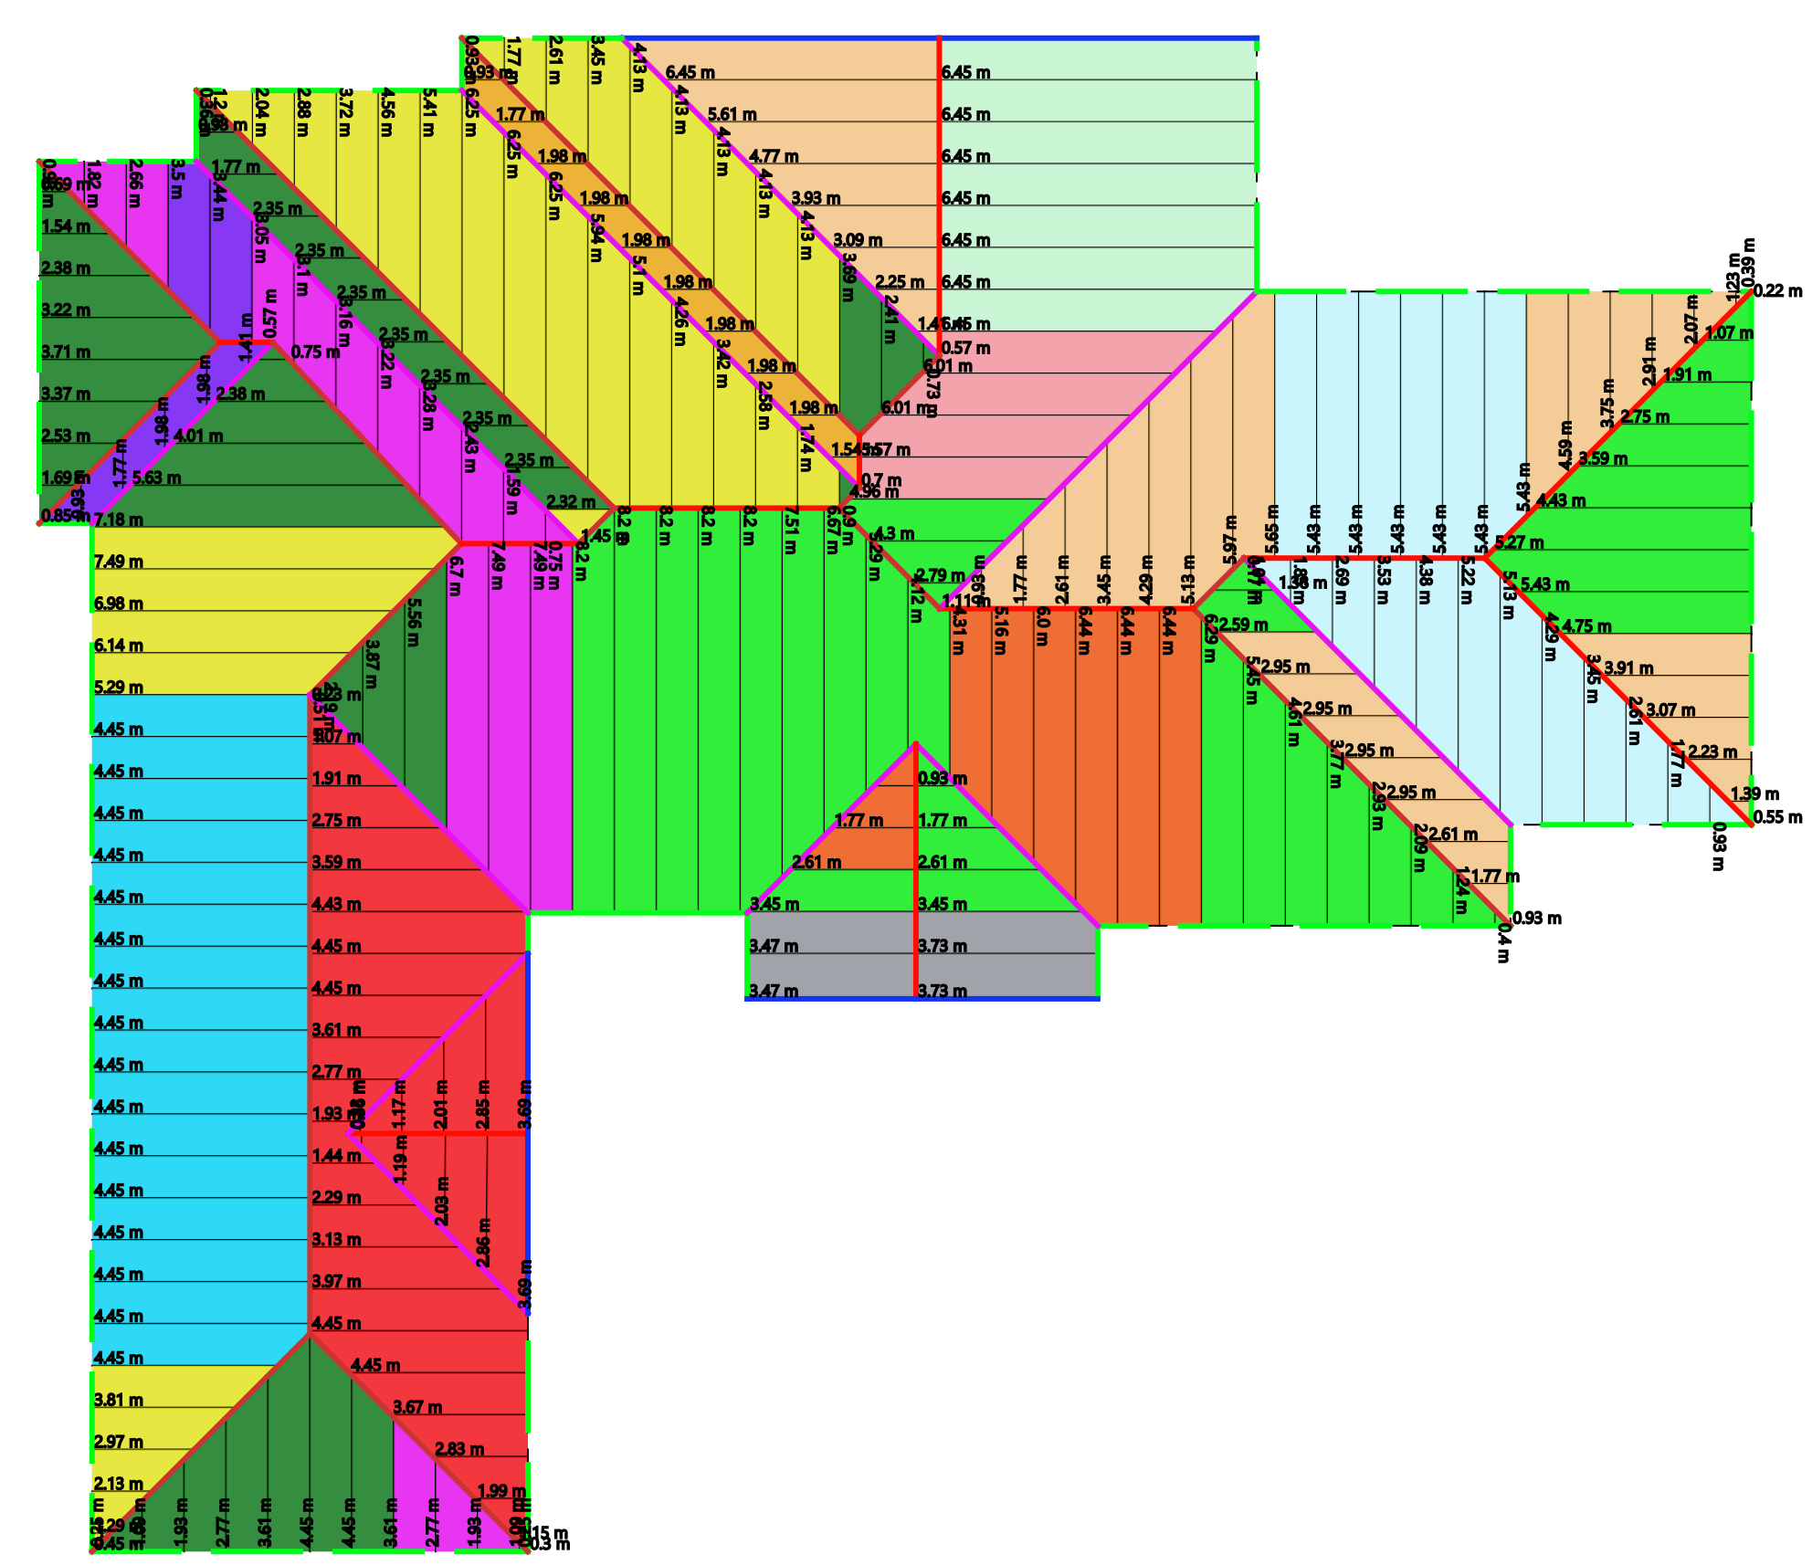

Material Outputs

Panel Color Linking table
Layers | Color | Material Name | No. of Panels | Panel Length | Pitch | Total Length | Area | Waste Factor
Roof 1 |  | Corrugated-Colour | 17 | 8.2 m | 25 | 139.4 m | 106.23 m²
Roof 1 |  | Corrugated-Colour | 13 | 8.2 m | 25 | 106.6 m | 81.23 m²
Roof 1 |  | Corrugated-Colour | 2 | 8.0 m | 25 | 16.0 m | 12.2 m²
Roof 1 |  | Corrugated-Colour | 16 | 7.49 m | 25 | 119.84 m | 91.32 m²
Roof 1 |  | Corrugated-Colour | 7 | 7.49 m | 25 | 52.43 m | 39.96 m²
Roof 1 |  | Corrugated-Colour | 16 | 6.45 m | 25 | 103.2 m | 78.64 m²
Roof 1 |  | Corrugated-Colour | 7 | 6.45 m | 25 | 45.15 m | 34.41 m²
Roof 1 |  | Corrugated-Colour | 6 | 6.44 m | 25 | 38.64 m | 29.45 m²
Roof 1 |  | Corrugated-Colour | 4 | 6.01 m | 25 | 24.04 m | 18.32 m²
Roof 1 |  | Corrugated-Colour | 12 | 5.43 m | 25 | 65.16 m | 49.66 m²
Roof 1 |  | Corrugated-Colour | 16 | 4.45 m | 25 | 71.2 m | 54.26 m²
Roof 1 |  | Corrugated-Colour | 16 | 4.45 m | 25 | 71.2 m | 54.26 m²
Roof 1 |  | Corrugated-Colour | 4 | 3.73 m | 25 | 14.92 m | 11.37 m²
Roof 1 |  | Corrugated-Colour | 4 | 3.71 m | 25 | 14.84 m | 11.31 m²
Total |  |  | 140 |  |  | 882.62 m | 672.62 m² | 14.56%

Flashing Cutting List
Layer | Item Description | Cutting list | Total
Roof 1 | Barge | 1/6.0 m, 1/3.9 m, 1/3.7 m, 1/3.6 m, 1/3.5 m, 2/3.4 m | 27.5 m
Roof 1 | Metal Fascia CB | 1/8.1 m, 1/7.7 m, 1/6.7 m, 1/6.5 m, 3/6.3 m, 1/5.9 m, 3/5.0 m, 1/4.8 m, 2/4.6 m, 2/4.5 m, 1/4.1 m, 1/3.8 m, 1/3.6 m, 1/3.5 m, 1/3.4 m, 1/3.1 m, 1/3.0 m, 1/2.0 m, 1/1.7 m, 1/1.5 m, 1/1.4 m, 2/1.1 m, 1/0.9 m | 126.0 m
Roof 1 | Quad Gutter CB | 1/8.4 m, 1/8.0 m, 1/7.0 m, 3/6.5 m, 1/5.3 m, 3/5.1 m, 4/4.8 m, 1/4.4 m, 1/3.4 m, 1/3.3 m, 1/2.3 m, 1/2.0 m, 1/1.8 m, 1/1.7 m, 2/1.4 m, 1/1.2 m | 105.6 m
Roof 1 | Rolltop Ridge CB | 2/7.9 m, 1/7.0 m, 2/6.5 m, 2/6.2 m, 2/6.1 m, 1/5.9 m, 2/5.8 m, 2/5.5 m, 2/5.3 m, 1/5.0 m, 4/4.7 m, 1/4.3 m, 1/3.4 m, 2/2.8 m, 1/2.0 m, 3/1.6 m, 1/1.2 m | 144.6 m
Roof 1 | Valley CB | 1/8.0 m, 1/6.6 m, 2/5.8 m, 1/5.7 m, 5/5.6 m, 1/5.3 m, 4/4.7 m | 84.0 m

Batten Cutting List
Layer | Item Description | Cutting list | Total
Roof 1 | Roof Batten 40MM | 161/6.5 m | 1046.5 m

Accessories
Layer | Type | Item Description | Total
Roof 1 | Flashing Accessory | Barge Mould LH | 104.0 Each
Roof 1 | Flashing Accessory | Barge Mould RH | 104.0 Each
Roof 1 | Flashing Accessory | Fascia Cnr Ext | 52.0 Crn(s)
Roof 1 | Flashing Accessory | Fascia Cnr Int | 26.0 Crn(s)
Roof 1 | Flashing Accessory | Over Strap | 118.0 Each
Roof 1 | Flashing Accessory | Pop | 16.0 Pop(s)
Roof 1 | Flashing Accessory | Quad Ext Cnr | 80.0 Crn(s)
Roof 1 | Flashing Accessory | Quad Int Cnr | 20.0 Crn(s)
Roof 1 | Flashing Accessory | Rafter Brackets | 210.0 Each
Roof 1 | Flashing Accessory | Spring Clips | 118.0 Each
Roof 1 | Flashing Accessory | Stop End Left | 60.0 Each
Roof 1 | Flashing Accessory | Stop End Right | 60.0 Each
Roof 1 | Batten Accessory | BATTEN ZIP | 4516.0 Zip(s)
Roof 1 | Panel Accessory | Anitcon 55 | 36.0 Roll(s)
Roof 1 | Panel Accessory | Roof Zip 50mm | 5285.0 Screw(s)

Point Items
Layer | Item Description | Total | Price | Total Price
Total |  |  |  | 0.0
Labor
Layer | Type | Item Description | Total | Price | Total Price
Roof 1 | Batten Labor | Batten Labour | 1261.0 Lm | 2.0 | 2522.0
Roof 1 | Panel Labor | Roof Labour | 588.0 m² | 6.0 | 3528.0
Roof 1 | Flashing Labor | Fascia Labour | 122.0 Lm | 2.5 | 305.0
Roof 1 | Flashing Labor | Gutter Labour | 96.0 Lm | 2.5 | 240.0
Total |  |  |  |  | 6595.0

